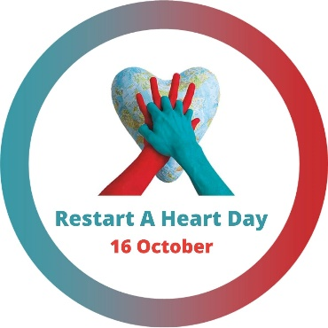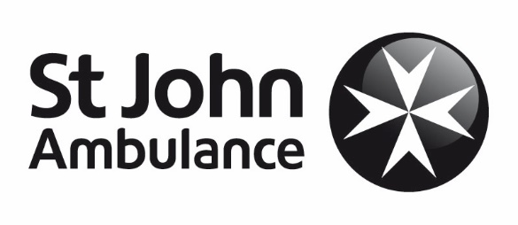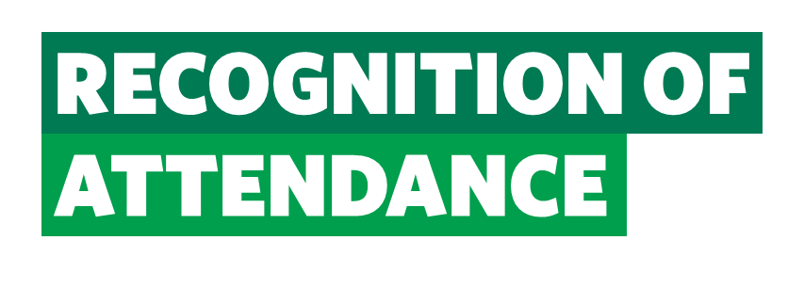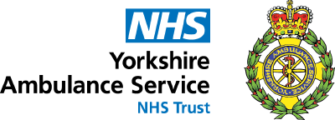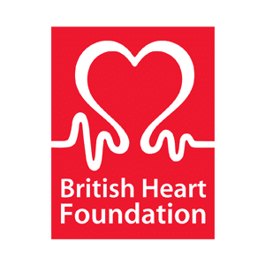

©2021 St John Ambulance | Charity no. 1077265/1 | BC17031

attended a CPR session, learning life-saving skills as part of Restart a Heart, including:

* the approach and response to an emergency situation
* how to identify an unresponsive casualty that is not breathing
* the difference between a heart attack and cardiac arrest
* the skills to give cardio-pulmonary-resuscitation (CPR) to adults, babies and children (with Covid-19 safe practice)
* the knowledge of how to use an automated external defibrillator (AED)

25/06/2021

**sja.org.uk**

Find out more

**sja.org.uk/get-advice**

Get advice

**sja.org.uk/app**

Download the app

NAME