**FILL IN THE BLANKS**

Activity A26

Choking

From the words below, fill in the blanks to make the correct sentence.

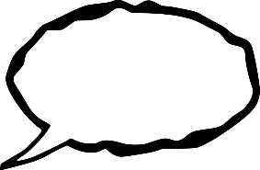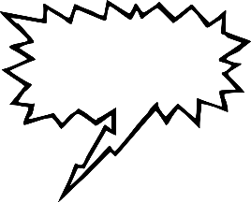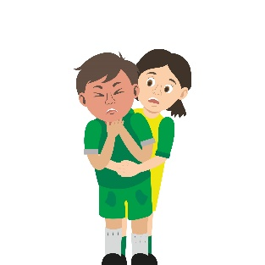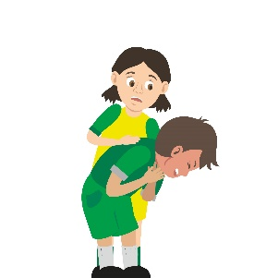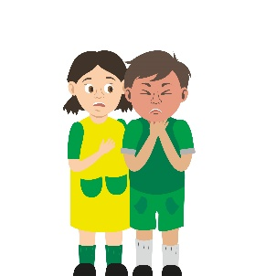



**thrusts**

**airway**

**throat**

**blocked**

**choking**

**face**

**back blows**

**999**

**cough**

**breathing**

**five**

A person who is _____ is in serious danger because their airway is _____. You can tell if someone is choking because:

* They will have difficulty speaking or _____.
* Their _____ will go a red or purple colour.
* They might even point at their _____.

There are some simple things you can do to help a choking person, by clearing their _____.

Firstly, ask the person if they are choking. Next, ask them to try and _____ out the object that is blocking their airway. If that doesn’t work, give the person five sharp __________ between their shoulder blades. If their airway is still blocked, try to squeeze the object out by giving up to _____ abdominal _____. Finally, if they are still choking call _____.