**CHOKING WORDSEARCH**

Activity A23

Choking

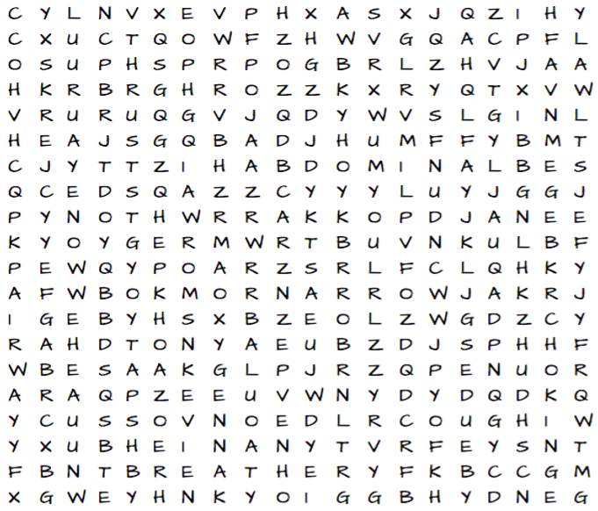

C

|  |  |  |
| --- | --- | --- |
| * NARROW * ABDOMINAL * OXYGEN * COUGH | * BLOCKAGE * BACKBLOWS * LUNGS * THRUSTS | * CHOKING * BREATHE * ASTHMA * AIRWAY |

